Global ESG Map
How do we know ESG is working around the globe?
The increasing adoption of ESG frameworks by individuals, communities, organizations, governments, and regulators worldwide is a strong indicator of ESG's effectiveness and relevance. Let's explore what has been happening around the world.
Governments
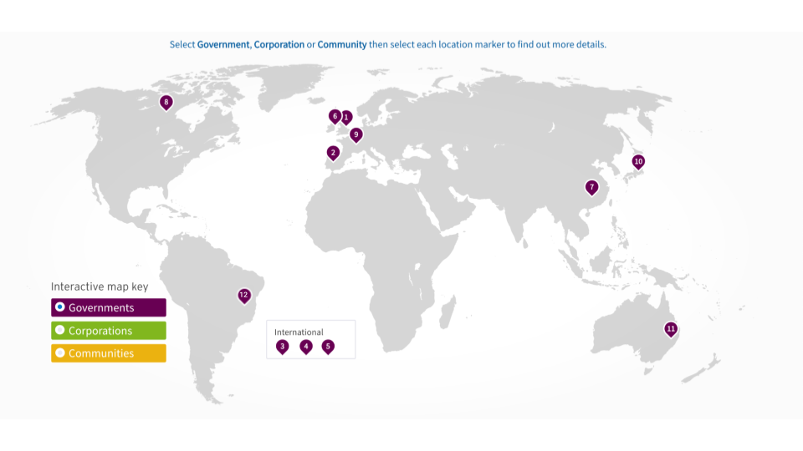
1. Modern Slavery Act 2015 (United Kingdom). This legislation requires companies with a turnover above a certain threshold to disclose the steps they have taken to address modern slavery in their supply chains.
2. European Green Deal (European Union). The European Green Deal is a comprehensive policy framework launched by the European Commission, aiming to make Europe the world's first climate-neutral continent by 2050. It sets ambitious targets for reducing greenhouse gas emissions, promoting renewable energy, and transitioning to a circular economy.
3. International Task Force on Climate-related Financial Disclosures (TCFD). The TCFD, established by the Financial Stability Board, developed a set of recommendations for companies and financial institutions to disclose climate-related risks and opportunities. It has gained global recognition and support from governments, central banks, and businesses.
4. Sustainable Development Goals (SDGs) (United Nations). The SDGs are a collection of 17 global goals adopted by the United Nations member states to address social, economic, and environmental challenges. Governments around the world have committed to implementing the SDGs, aligning their policies and strategies with the sustainable development agenda.
5. Paris Agreement (United Nations Framework Convention on Climate Change). The Paris Agreement is an international treaty aimed at combating climate change by limiting global warming to well below 2 degrees Celsius above pre-industrial levels. Signatory countries commit to regularly reporting their greenhouse gas emissions and implementing mitigation and adaptation measures.
6. UK Green Finance Strategy (United Kingdom). The UK Green Finance Strategy outlines the government's plan to mobilize private finance for green investments. It includes measures to increase transparency, develop green financial products, and integrate climate-related risks into financial decision-making.
7. China's Green Finance Guidelines (China). The Chinese government has issued guidelines to promote the development of green finance, encouraging financial institutions to support environmentally friendly projects and disclose relevant information.
8. Sustainable Finance Strategy (Canada). The Canadian government has introduced a sustainable finance strategy to advance the integration of climate-related and environmental considerations into the financial system. It aims to mobilize private capital for sustainable investments and enhance the resilience of the financial sector.
9. Climate Action Plan 2050 (Germany). Germany's Climate Action Plan 2050 outlines a long-term strategy to achieve greenhouse gas neutrality by mid-century. It includes sector-specific targets, policies, and measures to transition to a low-carbon economy.
10. ESG Reporting and Disclosure Requirements (Japan). The Japanese Financial Services Agency has introduced guidelines and disclosure requirements for companies to enhance transparency and disclosure of ESG-related information.
11. Sustainability and Climate Risk (SCRI) Initiative (Australia). The SCRI initiative by the Australian Prudential Regulation Authority (APRA) seeks to integrate climate-related risks and opportunities into the financial sector's decision-making and risk management processes.
12. Brazilian Forest Code (Código Florestal Brasileiro). The Forest Code is a comprehensive legislation in Brazil that aims to regulate the use and conservation of forests, including the Amazon rainforest, and promote sustainable land management practices.
Corporations
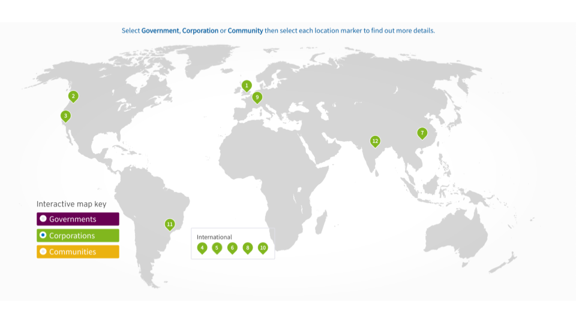
1. Unilever Sustainable Living Plan (Unilever). Unilever's Sustainable Living Plan is a comprehensive strategy focused on sustainable sourcing, reducing environmental impact, and improving social welfare. It includes goals such as sourcing 100% sustainable palm oil and achieving a positive social impact through various initiatives.
2. Microsoft Carbon Negative Commitment (Microsoft). Microsoft has made a landmark commitment to be carbon negative by 2030 and remove all its historical carbon emissions by 2050. The company is investing in renewable energy, energy efficiency, and carbon capture technologies to achieve these goals.
3. Patagonia's Environmental and Social Initiatives (Patagonia). Patagonia is known for its strong commitment to environmental and social responsibility. The company has implemented initiatives such as the "Worn Wear" program to promote product durability and repair, as well as supporting grassroots environmental organizations through its "1% for the Planet" program.
4. IKEA People & Planet Positive Strategy (IKEA). IKEA's People & Planet Positive strategy aims to become a circular and climate-positive business by 2030. The company focuses on renewable energy, sustainable sourcing, and waste reduction to achieve these goals.
5. Tesla's Electric Vehicle Revolution (Tesla). Tesla has been a pioneer in the electric vehicle industry, driving the global transition to sustainable transportation. The company's commitment to producing high-performance electric vehicles has played a significant role in advancing the adoption of clean and renewable energy.
6. Danone's One Planet. One Health Initiative (Danone). Danone's One Planet. One Health initiative encompasses various sustainability commitments, including reducing greenhouse gas emissions, promoting sustainable agriculture, and improving water stewardship.
7. Tencent's Green Initiative (China). Tencent, a Chinese multinational conglomerate, has launched its Green Initiative, aiming to reduce carbon emissions and promote sustainable development. The company focuses on renewable energy, energy efficiency, and green data centers.
8. Starbucks Coffee and Farmer Equity (C.A.F.E.) Practices (Starbucks). Starbucks' C.A.F.E. Practices program ensures the ethical sourcing of coffee beans, promotes sustainable farming practices, supports farmers' livelihoods, and protects the environment.
9. Nestlé's Creating Shared Value (Nestlé). Nestlé's Creating Shared Value approach integrates social and environmental considerations into its business operations. The company focuses on responsible sourcing, nutrition, water stewardship, and rural development to create value for both the business and society.
10. Cemex's Sustainable Construction Initiatives (Cemex). Cemex, a Mexican multinational building materials company, has implemented various initiatives to promote sustainable construction practices. This includes reducing carbon emissions, optimizing water usage, and incorporating sustainable materials in its products.
11. Fibria's Forest Stewardship Commitments (Fibria). Fibria, a Brazilian pulp and paper company, has made significant commitments to sustainable forest management. The company implements practices to protect biodiversity, conserve water resources, and promote reforestation.
12. HUL's Sustainable Living Plan (India). Hindustan Unilever Limited (HUL), an Indian subsidiary of Unilever, has implemented its Sustainable Living Plan. The plan focuses on sustainable sourcing, reducing environmental impact, and improving livelihoods through various initiatives.
Communities
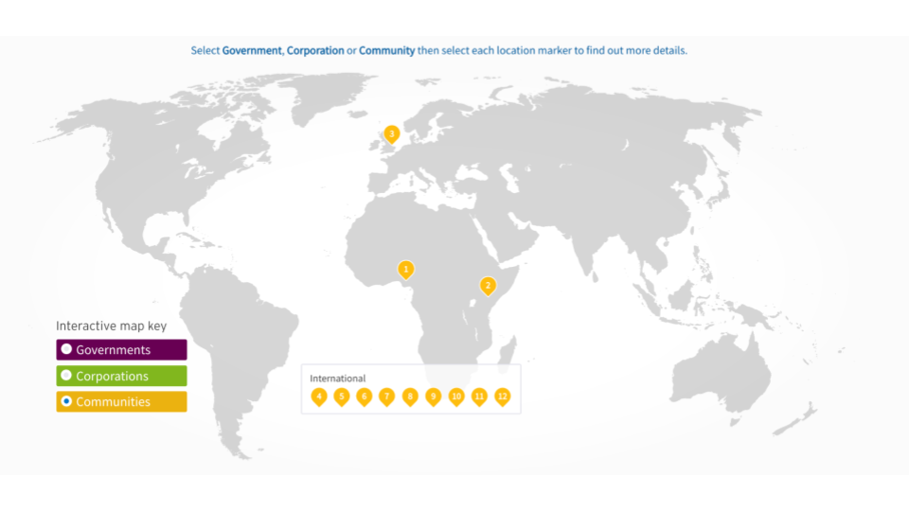
1. Ogoni People's Protest (1990s) - Niger Delta, Nigeria. The Ogoni People's Protest, led by activist Ken Saro-Wiwa, aimed to address environmental degradation and the impact of oil extraction on local communities in the Niger Delta. The movement drew international attention to the need for environmental justice, and sustainable practices and initiatives.
2. Community-Led Forest Management (Various Locations). Communities worldwide have implemented community-led forest management initiatives, empowering local stakeholders in sustainable forestry practices, conservation efforts, and the preservation of traditional knowledge. Examples include community forest initiatives in Nepal and community-based conservation projects in Kenya.
3. Transition Town Movement (2005) - Totnes, United Kingdom. The Transition Town Movement started in Totnes, UK, and has spread globally. It focuses on community-led initiatives to build resilience, promote sustainable practices, and reduce dependency on fossil fuels at the local level.
4. Fair Trade Movement (1970s) - Global. The Fair Trade movement, originating in various locations, promotes ethical and sustainable trading practices. Consumers actively choose products with Fair Trade certification, ensuring fair prices, social development, and environmental sustainability for producers in developing countries.
5. Responsible Investment and Divestment Campaigns (Various Locations). Consumers have influenced investment decisions through responsible investment and divestment campaigns. Examples include fossil fuel divestment movements and shareholder activism to push for sustainable practices in corporations.
6. Ethical Fashion and Slow Fashion Movements (Various Locations). Consumers have pushed for sustainable and ethical practices in the fashion industry. The movements advocate for fair wages, safe working conditions, reduced environmental impact, and conscious consumption.
7. Certification Programs for Responsible Products (Various Locations). Consumers look for certification programs such as Energy Star, Forest Stewardship Council (FSC), and B Corp to ensure products meet specific environmental and social standards. These programs provide transparency and assurance to consumers.
8. Single-Use Plastic Reduction Initiatives (Various Locations). Consumer awareness about plastic pollution has led to widespread initiatives to reduce single-use plastics. Bans on plastic bags, campaigns for reusable alternatives, and demand for plastic-free packaging have gained traction globally.
9. Conflict-Free Minerals Movement (2000s) - Democratic Republic of the Congo and Global. Consumers pushed for conflict-free minerals, particularly in the electronics industry, to address the issue of conflict financing and human rights abuses in regions like the Democratic Republic of the Congo. The movement led to greater transparency and responsible mineral sourcing.
10. Anti-Sweatshop Movement (1990s-2000s) - Global. Consumers demanded better working conditions and fair wages for workers in the garment and apparel industry. Activism and pressure on companies led to increased transparency, improved labor practices, and the establishment of fair trade certifications.
11. LGBTQ+ Rights Campaigns (Various Locations). Consumers have driven change through their support for LGBTQ+ rights. Boycotts, advocacy, and demand for inclusive practices have encouraged companies to embrace diversity, equality, and non-discrimination.
12. Indigenous Rights Movements (Various Locations). Consumer support for indigenous rights has influenced companies to respect indigenous land rights, protect cultural heritage, and engage in sustainable practices. Movements have focused on issues like land encroachment, resource extraction, and indigenous communities' self-determination.

